University Of Engineering and Technology, Lahore
Computer Engineering Department

Course Name: Programming Fundamentals | Course Code: CMPE-112L
Assignment Type: Lab Tasks | Dated: 02-03-2026
Semester: 1st | Session: Spring
Lab/Project/Assignment #: 2 | CLOs to be covered: CLO 1
Lab Title: For loop | Teacher Name: Hafiz Muhammad Mubashar
Lab Evaluation:

CLO1 | Apply appropriate programming techniques to create executable programs to solve well defined problems
 | Level1 | Level2 | Level3 | Level4 | Level5 | Level6
(5)
Total |  |  |  |  |  | /5
Rubrics for Current Lab Evaluation
Scale | Marks | Level | Rubric
Excellent | 5 | L1 | Submitted all lab tasks, BONUS task, have good understanding.
Very Good | 4 | L2 | Submitted the lab tasks but have good understanding
Good | 3 | L3 | Submitted the lab tasks but have weak understanding.
Basic | 2 | L4 | Submitted the lab tasks but have no understanding.
Barely Acceptable | 1 | L5 | Submitted only one lab task.
Not Acceptable | 0 | L6 | Did not attempt
LAB No 2
Lab Goals/Objectives:
The purpose of this lab is to learn how to use the Python for loop in different situations. We practiced printing values, working with lists, finding sums, creating patterns, and solving simple programming problems. This lab also improves logical thinking and coding skills.
Equipment Required:
Computer or Laptop, Python 3.x, PyCharm or Visual Studio Code.
Theory:
The for loop is used to repeat a block of code a fixed number of times or to iterate through a sequence. It works with the range() function, lists, and strings. For loops make programs shorter, easier to read, and useful for repetitive tasks.
Lab Work:
Task 1: Printed numbers from 1 to 10 using a for loop.
Result:
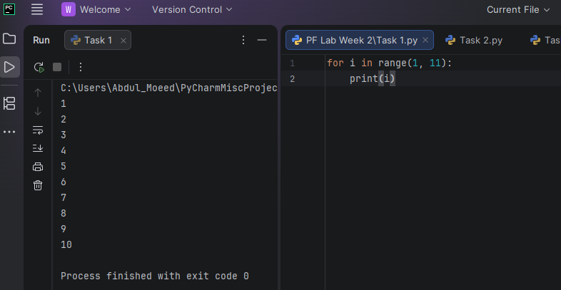

Task 2: Printed even numbers from 2 to 20.
Result:
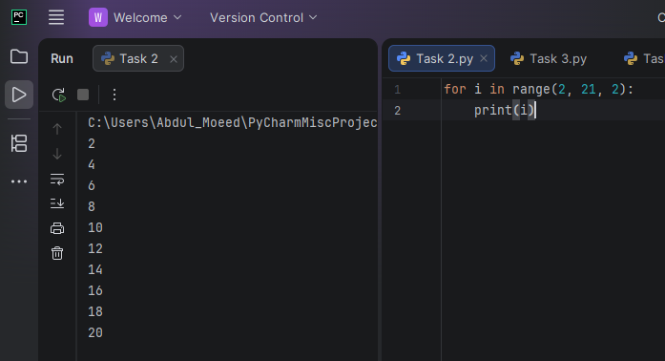

Task 3: Printed odd numbers from 1 to 19.
Result: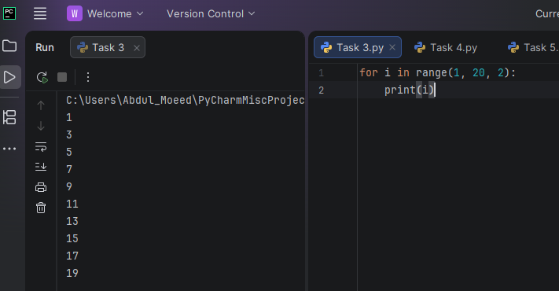

Task 4: Displayed all fruits stored in a list.
Result:
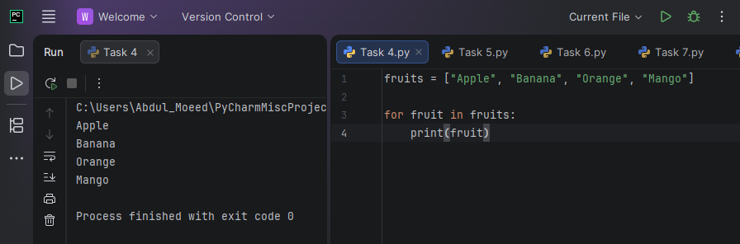

Task 5: Calculated the sum of numbers from 1 to 10.
Result:
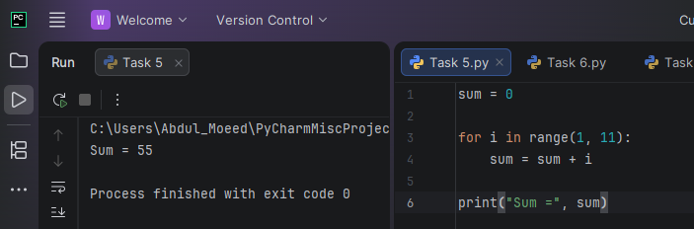

Task 6: Generated the multiplication table of a user-entered number.
Result:
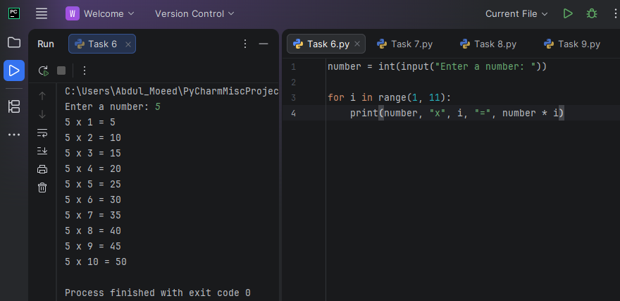

Task 7: Counted the vowels in a user-entered word.
Result:
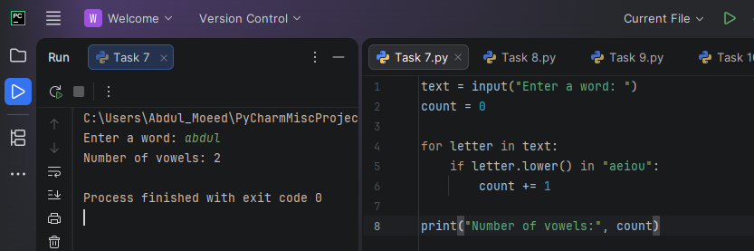
Task 8: Printed a left triangle star pattern.
Result:
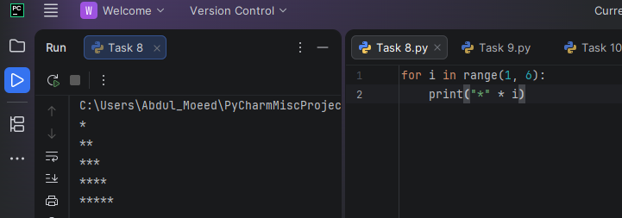
Task 9: Found the largest number in a list.
Result:
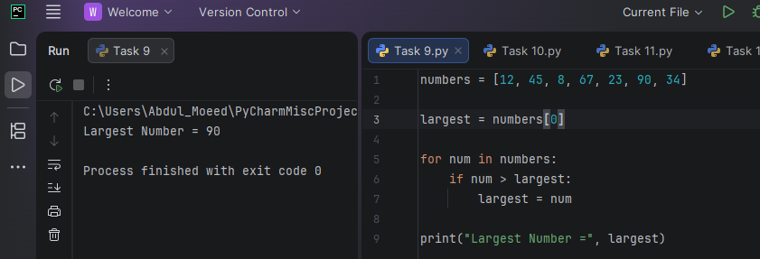

Task 10: Calculated total and average marks of five students.
Result:
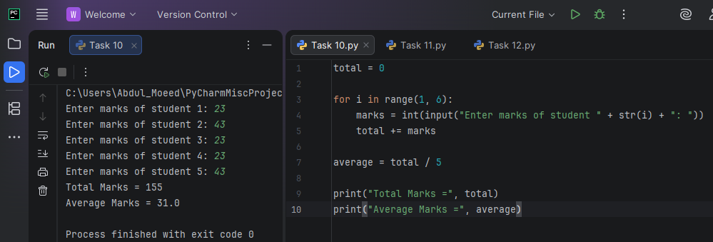

Task 11: Printed a pyramid star pattern.
Result:
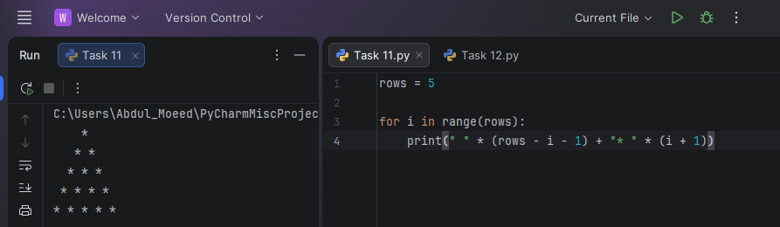

Task 12: Printed a diamond star pattern.
Result:
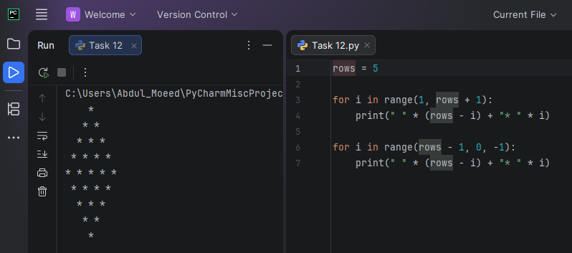

Conclusion:
In this lab, different programs were created using Python for loops. The tasks helped in understanding repetition, pattern generation, list traversal, and basic calculations. Overall, the lab improved programming logic and confidence in using loops.

